BRAS Bluebird Newsletter March 2023
The calendar tells us that Spring has finally arrived! The blooming crocuses, swelling maple buds and pairing of bluebirds have confirmed that the seasons are changing! The rough sawn cedar planks in our garage also are indicators that spring is here- they will soon be made into brand new bluebird boxes for our trails. Fritz enjoys working with wood and the smell is amazing!
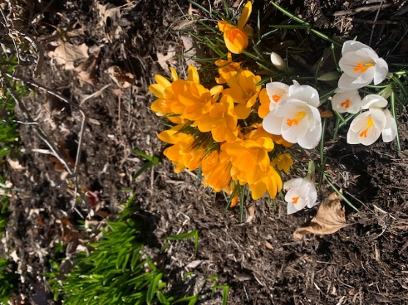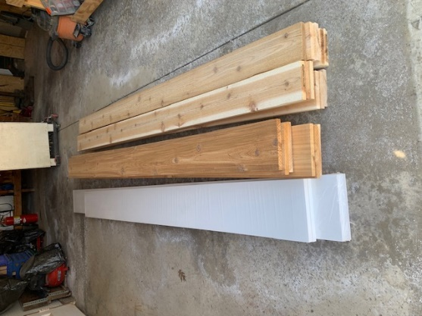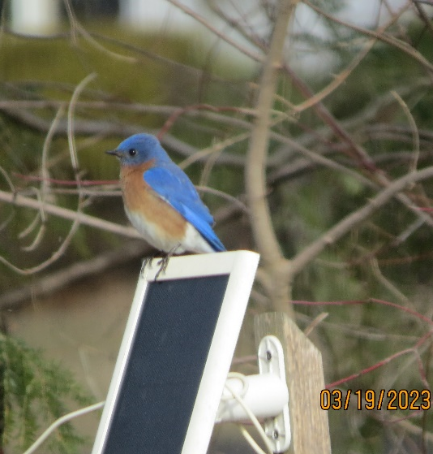
Each year in the March BRAS bluebird newsletter I ask for information about first bluebird eggs seen in area nest boxes because it is fun to celebrate these early milestones in our bluebird program. Please send me reports of your earliest eggs- bluebird, tree swallow, chickadee, or other native bird. Let’s celebrate together! I will mention these earliest egg arrivals in the next newsletter! Bluebird first eggs are usually in late March, tree swallows start in early May and black capped chickadee eggs normally are here in late April. House wren eggs start appearing sometime in mid to late May. Please let me know about your first eggs! A helpful link which shows the different types of eggs and nest of birds which might nest in a bluebird box can be found here. http://www.nabluebirdsociety.org/PDF/NABSFactsheetMonitoring.pdf
A mid March check of the nestboxes should be done to make sure the boxes are ready for nesting activity. After that check you should plan to start regularly monitoring your nestboxes every 4-7 days beginning around April 1 through early August. The Mid-March maintenance check however is crucial and needs to be done each year. Here are a few of the things to look for during that check:
Start at the top by looking at the box. Is the roof intact with no splits that might allow water to leak into the box? If you find minor cracks, some clear silicon caulking can be spread on them, but if there is significant weathering think about replacing the entire roof. Cold, wet chicks have increased mortality. Do the walls of the box have cracks or damage that also needs caulked? Are the floor drainage holes open? Is the box entrance hole smooth so that feathers aren’t torn when entering and exiting the box (a little sandpaper rubbing can help smooth out rough spots in the entrance hole). The hole should never be larger than 1 ½ inch so if it has become enlarged by woodpeckers or squirrels over the winter it should be fixed with replacement hole guards. Make sure that the Van ert screws are already in place inside the box, below the entrance hole, in case a non-native house sparrow decides to claim the box. Trap house sparrows early before they can kill native bluebirds or the tree swallows who also might want to nest in that particular box.
Mid March maintenance checks should also include inspection of the predator guard and pole. The Kingston predator guards used by Black River Audubon Society (and hopefully any private bluebird landlords reading this newsletter) should hang a few inches below the floor of the nestbox, should be able to wobble on the pole slightly and should not be touching either the ground or the actual nest box. They are highly effective in protecting the box contents from raccoons, snakes, chipmunks and other ground predators. Lastly, look at the pole that the box and predator guard are mounted on. The pole should not be leaning, the grass around the base of it should be cut short and briars or tall grasses should not be allowed to lean against the pole, predator guard or nest box itself. If
Pictured below (left) is trail monitor Deb Ackerman doing spring maintenance checks on one of the 27 nest boxes of the South Equestrian Trail at Carlisle Reservation. Pictured to the right is Monitor Bob Bement of Wakeman’s Dalton Park trail helping Fritz Brandau put in poles for 5 new nest boxes on a friend’s property. The new landlord, Betty Campbell, has already reported seeing bluebirds at the newly established boxes! Best wishes Betty!
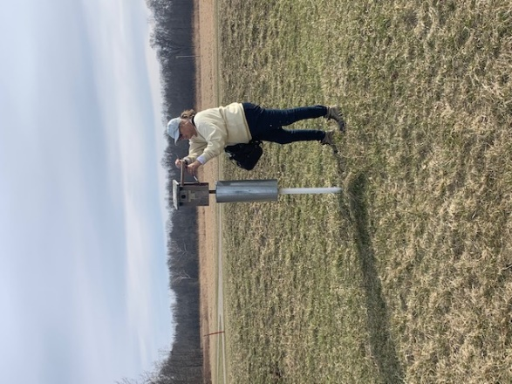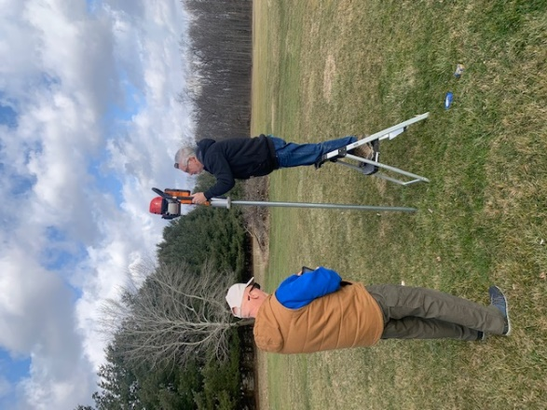
February and March were busy with several bluebird meetings. On Feb 25th we held a “Bluebird Basics” program at the Columbia Library. There were 47 attendees so the room was very full! The “show and tell” table, numerous bluebird informational handouts and bluebird family life videos were all welcomed by those attending the program. Lots of questions were answered and hopefully more bluebirds will be the result of that afternoon together. 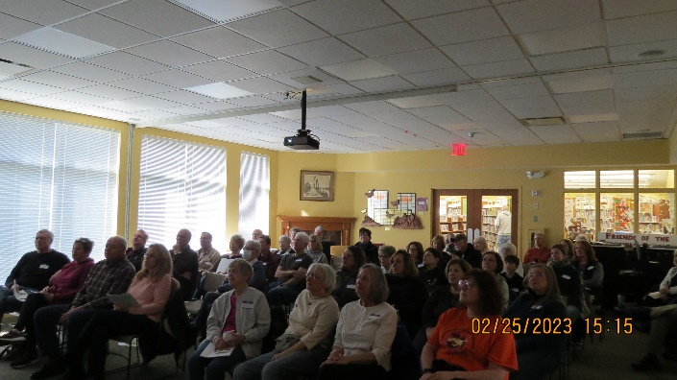 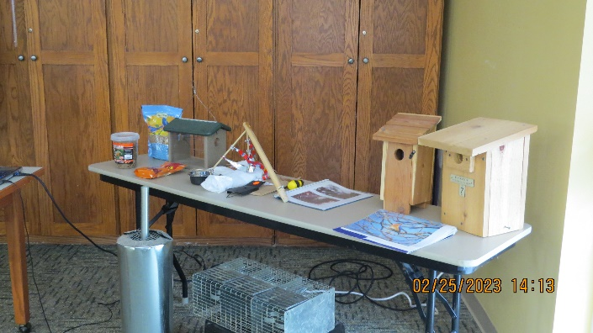
On March 4th the Ohio Bluebird Society held their yearly conference. This year they returned to an in-person format at the Ashland University campus after two years of virtual conferences during the Covid pandemic. Six members of Black River Audubon Society attended this year and enjoyed the comradery, the food, vendors, silent auction and the many varied agenda topics presented by several top notch speakers. BRAS member, Diana Steele, spoke about Bluebirding 101. Member and monitor Bob Bement made and donated a beautiful stained glass dragonfly for the Silent Auction fundraising event. This conference is worth attending year after year! It’s always fun to see so many fellow bluebird lovers-There were over 100 attendees this year from all over the state of Ohio.
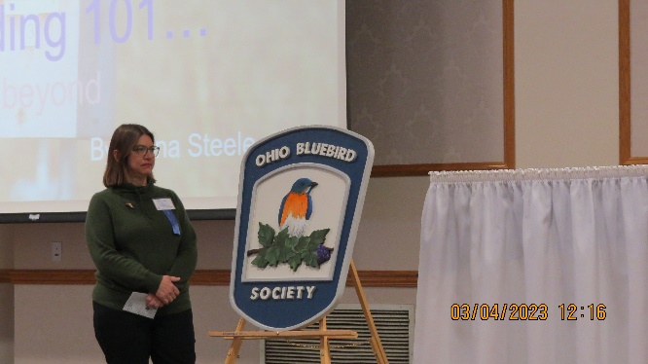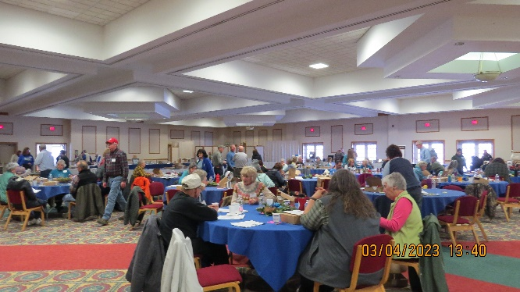
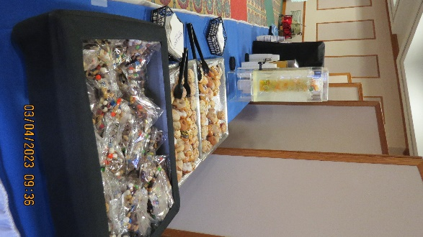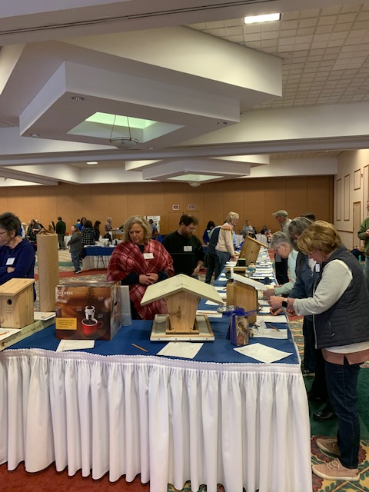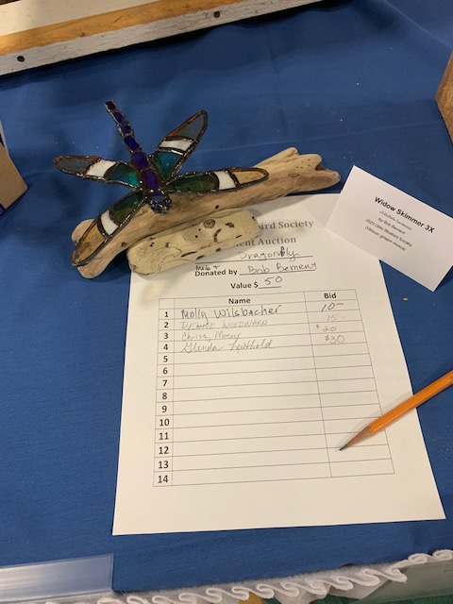
On March 11 the yearly Spring kickoff for all Black River Audubon Society monitors was held. We met at the Amherst Library and enjoyed a slideshow of trail photos from 2022, refreshments, review of recent trail work, demonstrations of some trail skills (like creating a replacement nest from dry grasses) and a chance to catch up with other trail monitors in our group! Lots of newly refurbished sparrow spookers and monitoring cards were taken home.
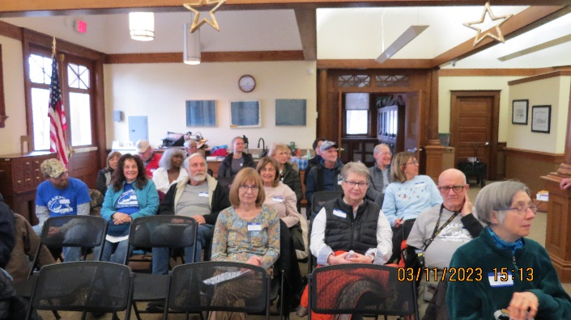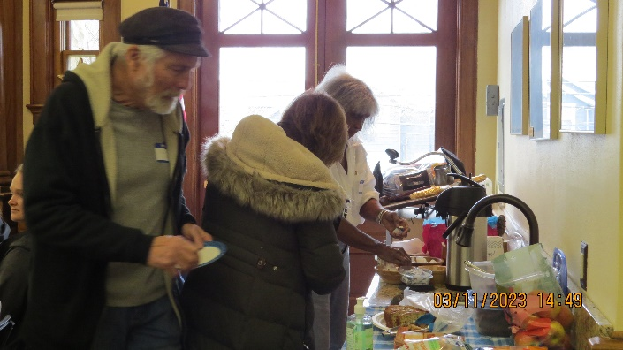
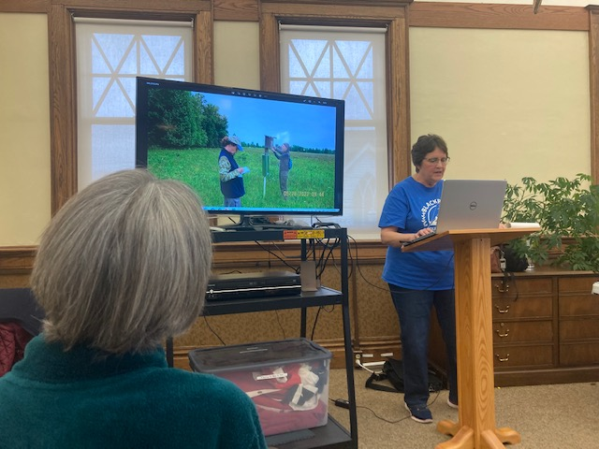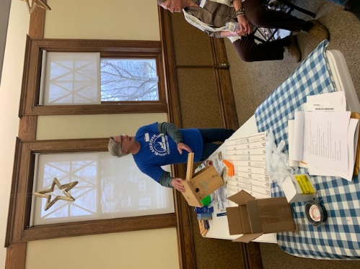
We would like to welcome new trail monitors for the Columbia Reservation- Len and Margie Taylor. Len and Margie live near Columbia and have been bluebird landlords for a few years. It is great to have them as part of our monitor group! Very cool to enjoy the sighting of a bluebird on our very first walk with them at Columbia last week too!
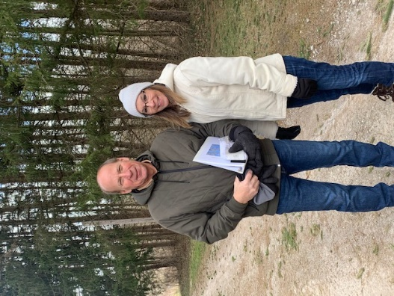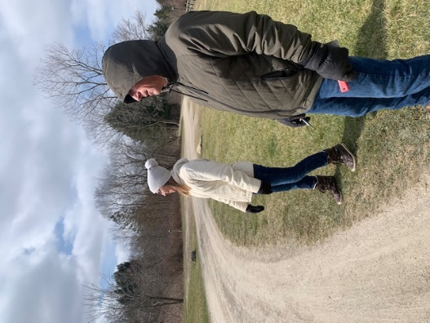
We appreciate all the monitoring work Sanjay and Indira Palekar have done at Columbia for the past several years and are glad they can transfer their monitoring care and knowledge to a trail closer to their home. They will be taking over the Indian Hollow trail this year as Bill Prescott is leaving to do more family traveling. We also want to thank retiring monitor Joe Gensert for his help the past three years as he partnered at Carlisle Visitor Center with Charlie Weil. We will miss Bill and Joe but wish them the best as they focus on different priorities this year!
If you meet any of the 48 bluebird trail monitors this year who will be walking the 31 bluebird trails we currently manage in the Lorain County area please thank them for their dedication, knowledge and care of the 470 bluebird boxes on those trails. They will be checking and taking notes on each nestbox every 4-7 days from April through August. They will walk in the gorgeous sunshine, as well as the cloudy, cold days, will deal with the joys of successful fledglings as well as the heartache of losses. They accept the unpleasant parts of trail monitoring like tiredness, heat, possible ticks, snakes and the all too often sight of house sparrow brutality to our native birds. They also will have the uncommon blessing of seeing a newly hatched bluebird and watching those chicks grow and fledge. They will watch bluebirds and swallows feed and defend their young and discover unexpected joys on each trail walk. They will know they are doing good in this world in a way that is deeply satisfying and rare.
Meetings are over, classes are done, and now it is time to hit the trails! Enjoy those opportunities to watch the miracle of nesting and help to make a difference in this world by caring for what we have been gifted- ourselves, others and the beauty of native cavity nesting birds like our beloved bluebirds! Wishing you the joy of bluebirds!
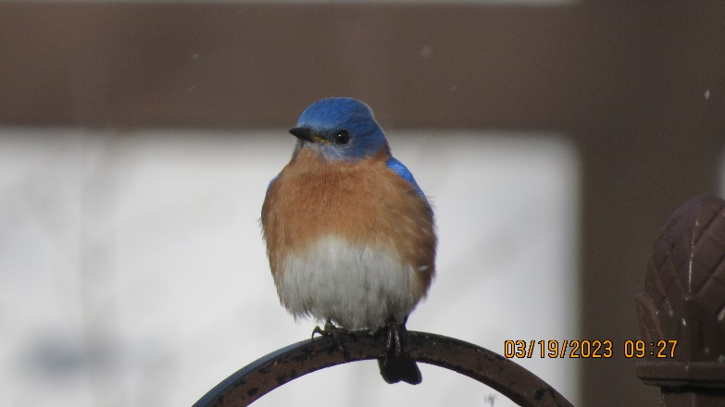
Newsletter by Penny Brandau pennybrandau@gmail.com 440-670-3684

